Pocketwatch: the Overwatch stats app.

Team:

Brian Sundberg

Project Objective:  
 To create and maintain an application that outlines and clearly conveys information about individual characters or ‘heroes’ from the popular class-based multiplayer shooter known as “Overwatch”.  
  
Site User Roles:  
 Admin : Brian Sundberg

Testing: Brian Sundberg

UI : Brian Sundberg

DB : Brian Sundberg

Code : Brian Sundberg

User stories

>Users will be able to select heroes and view information about them

>User will be able to select specific elements of a character’s “kit” for specific information.

>Users will be able to select a hero and submit that hero to a “counter recommendation engine” that will display a ‘counter list’ of other heroes that interact with the selected hero advantageously.

>Users will be able to interact with the aforementioned ‘counter list’ and be taken directly to the information about the character in question.

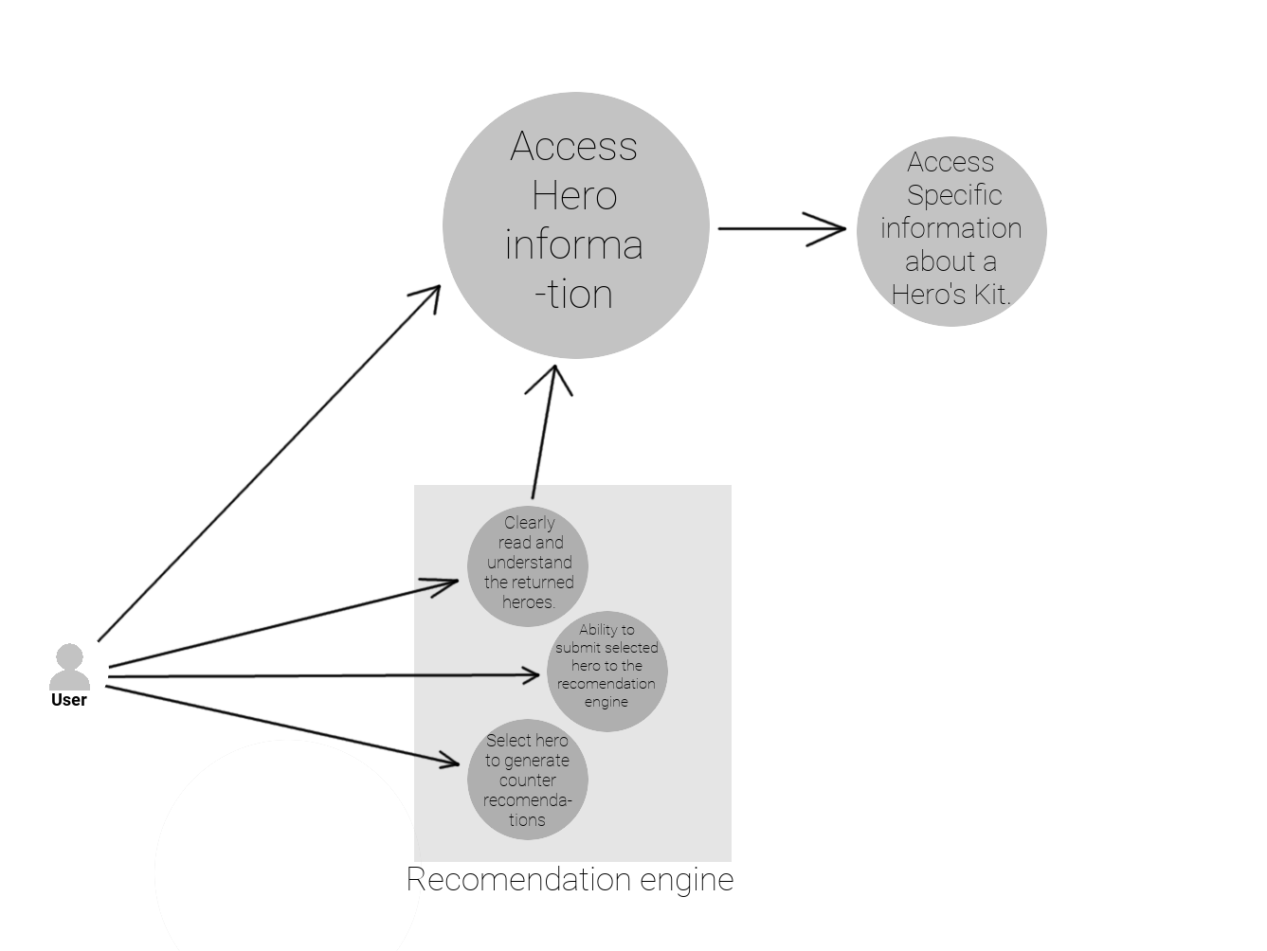

The purpose of this application is to inform users of the values of characters in the video game “Overwatch”. These characters will be refereed to as “Heroes” from this point on. Each hero has a unique combination of skills, roles, and attributes that sets them apart from the others. The 7 general slots these unique attribute can fall into are “Primary weapon or tool”, “Secondary weapon or tool”, “Ability 1”, “Ability 2”, “Ability 3” and an “Ultimate Ability”. The app must be able to clearly inform the user of these abilities and their numerical values.  
  
To this end the app must have a screen that allows users to see these values, as well as choose the hero they wish to select, mock-ups shown below, for desktop, demonstrate my design.

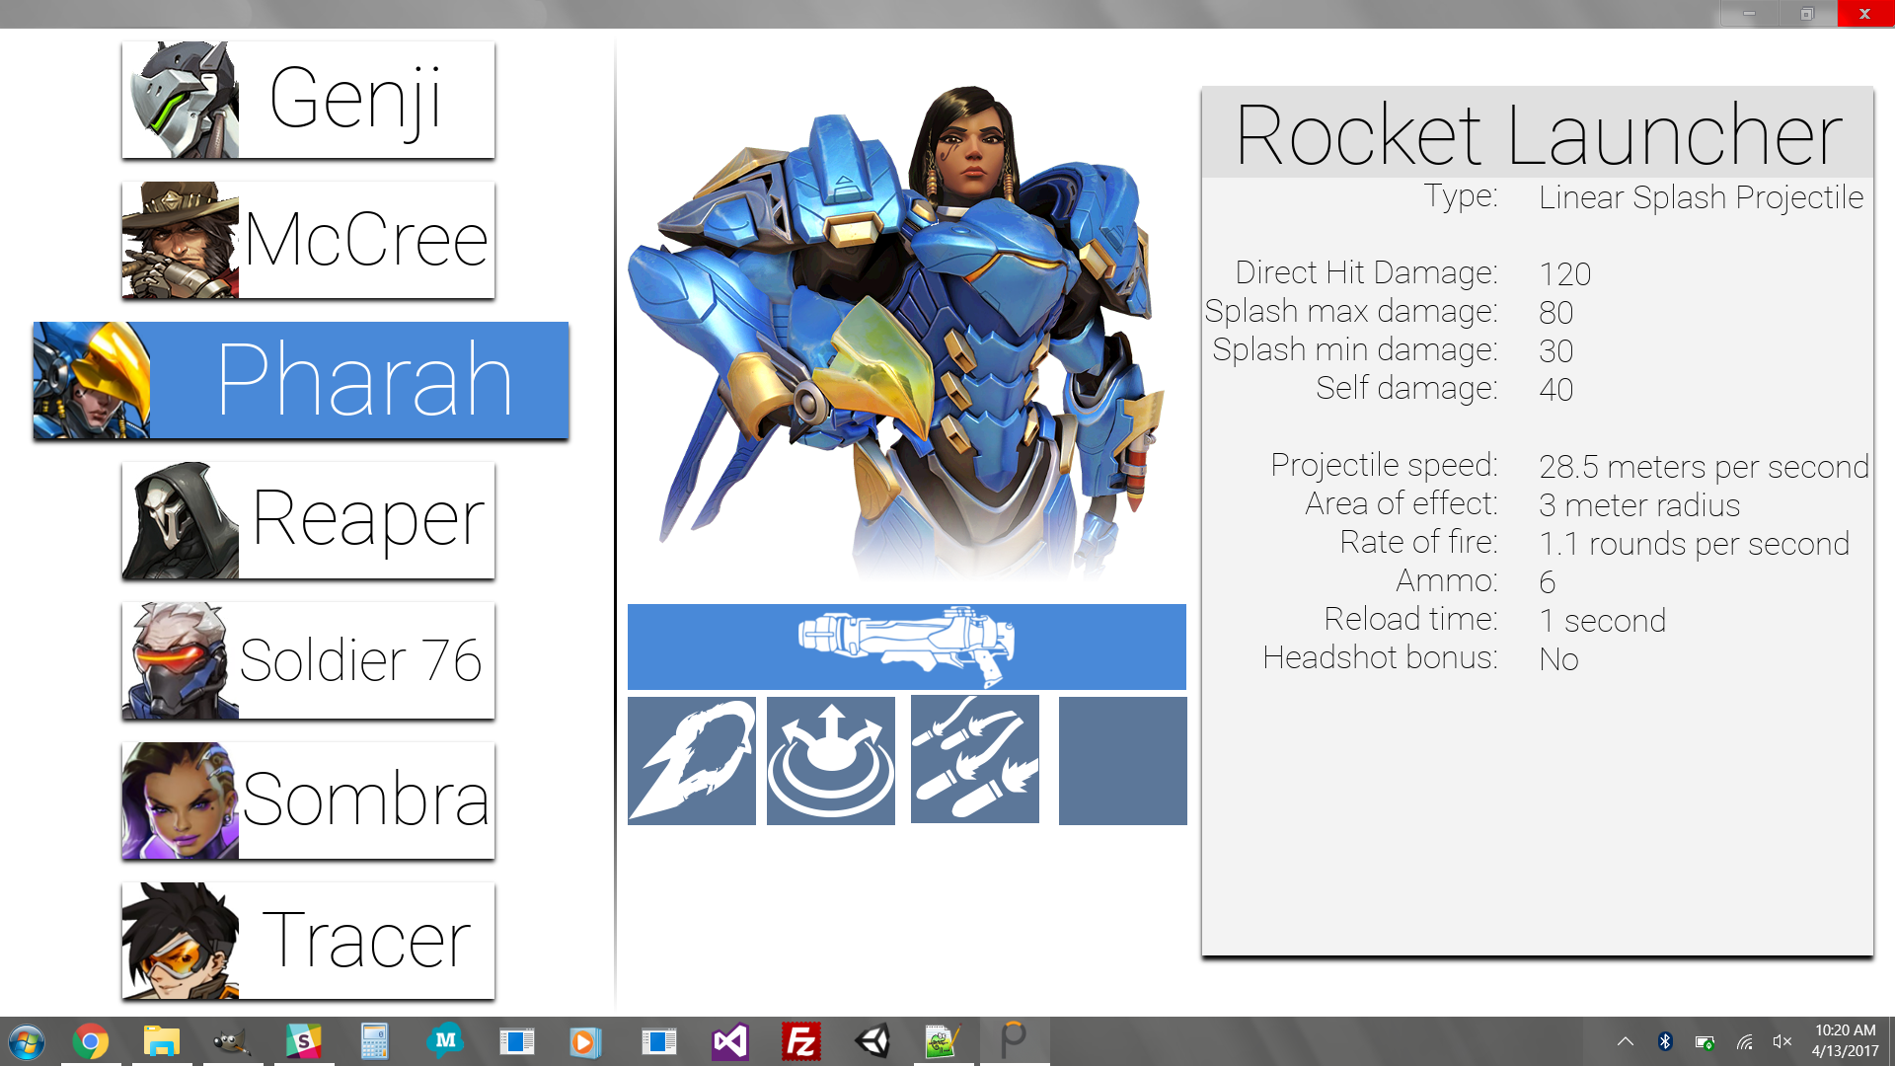

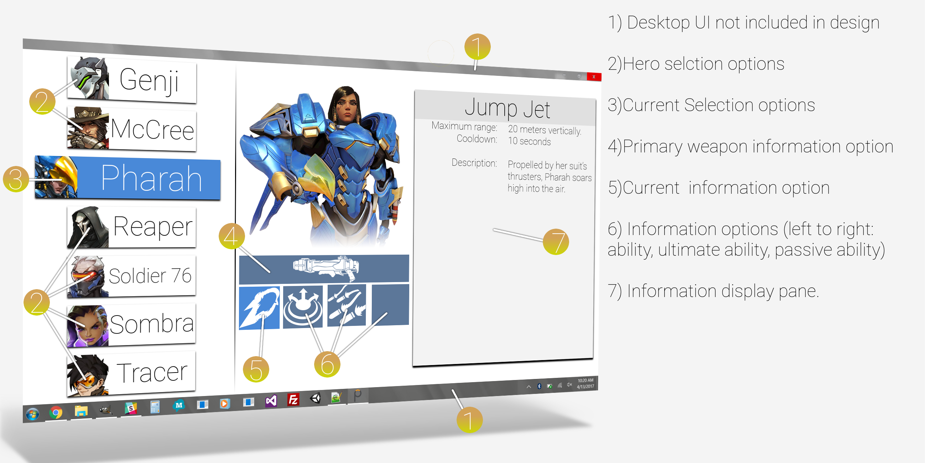

The application is a web app so support for mobile is also needed, and show below.

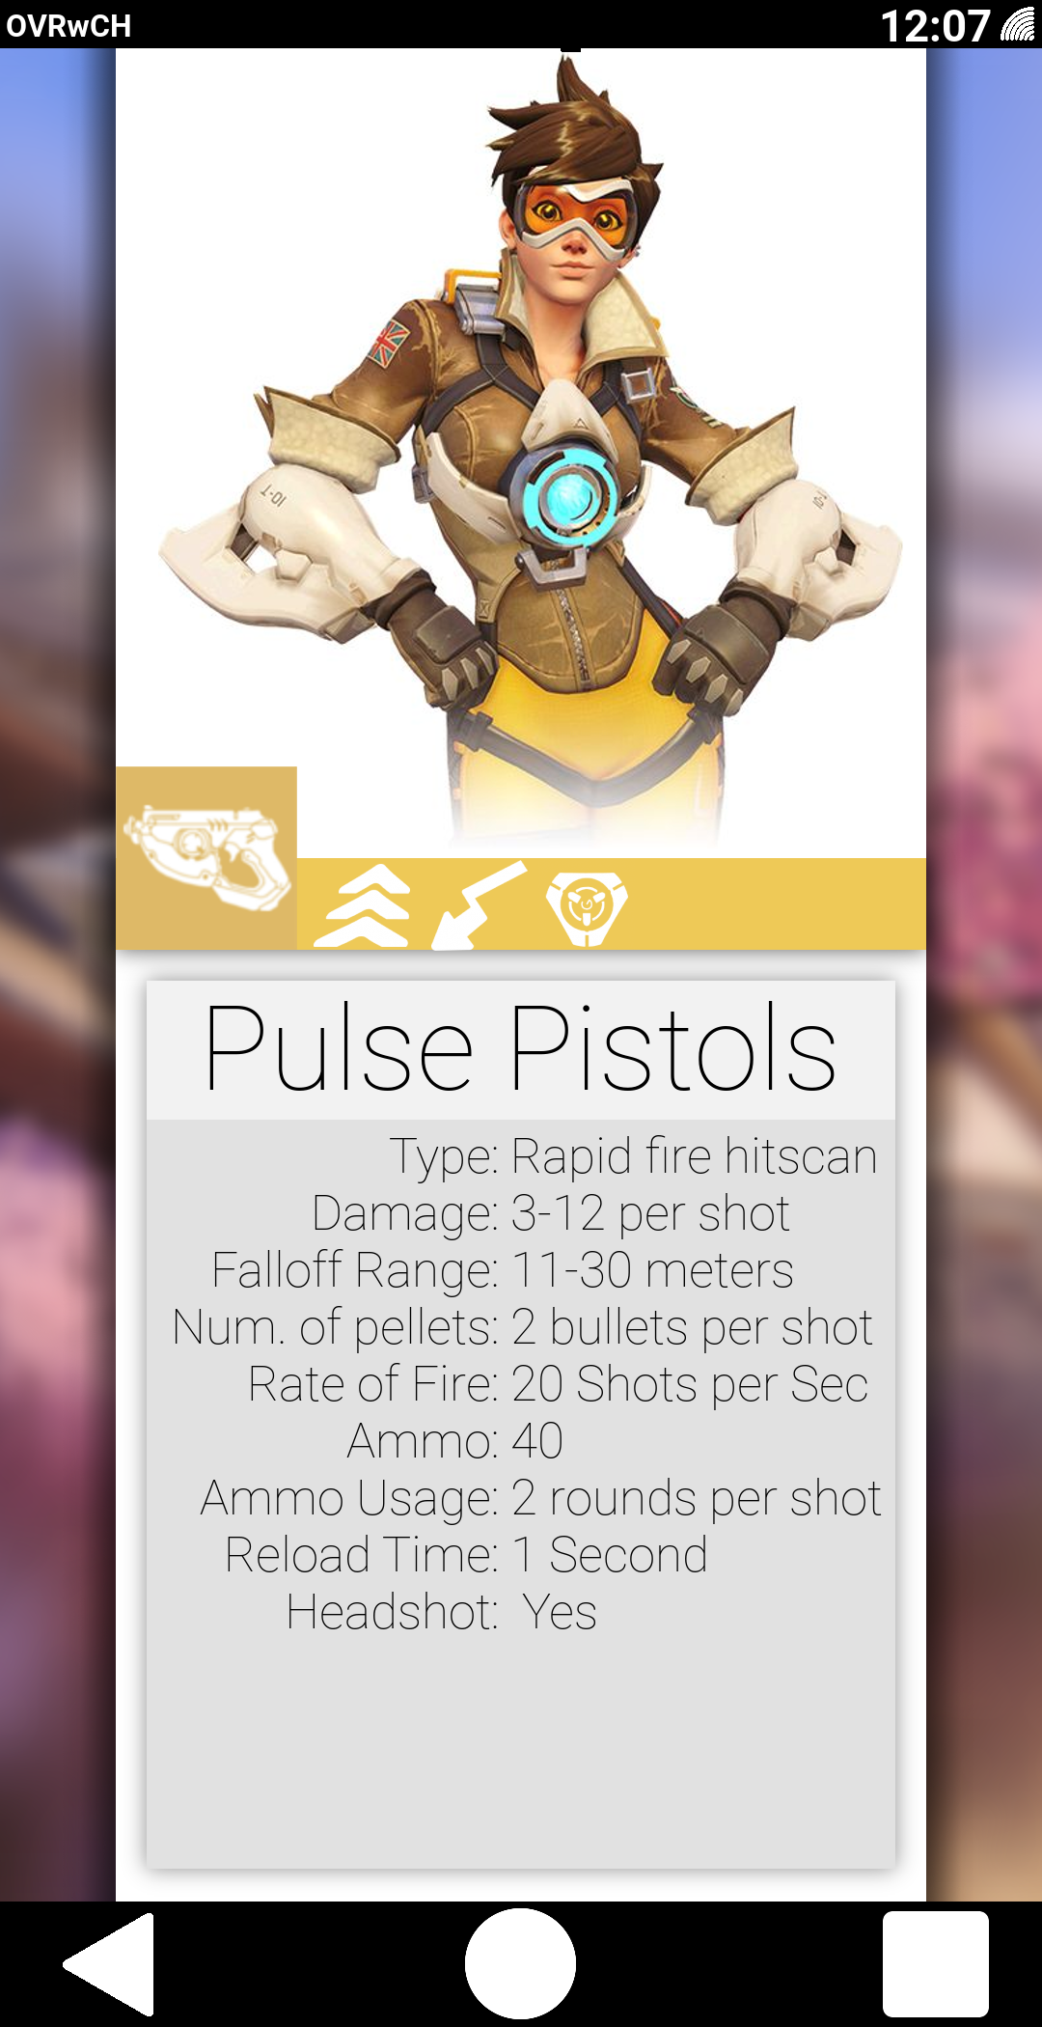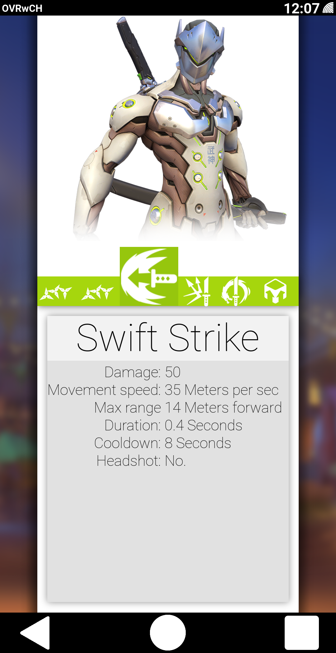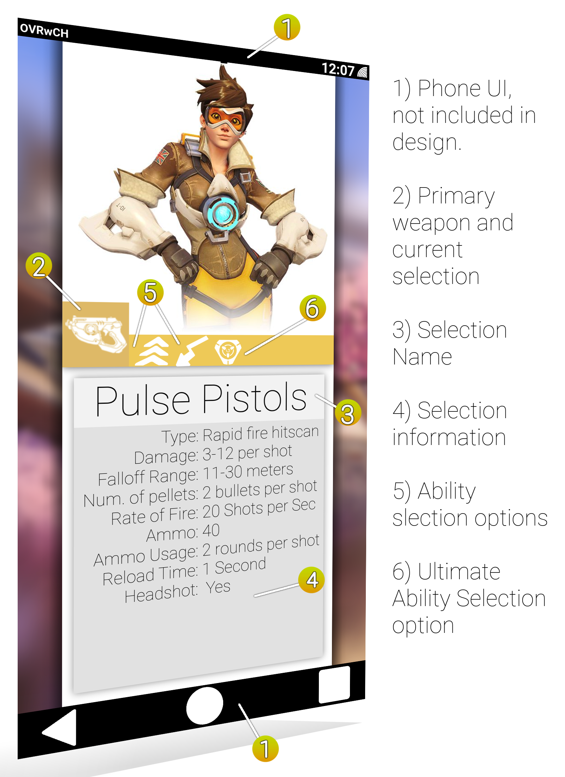

These screens show how the information about individual heroes would look on a mobile platform. Mobile devices have much less room to show information, meaning hero selection must take place on a separate page, the mock-up for which will be demonstrated on the next page of this document.

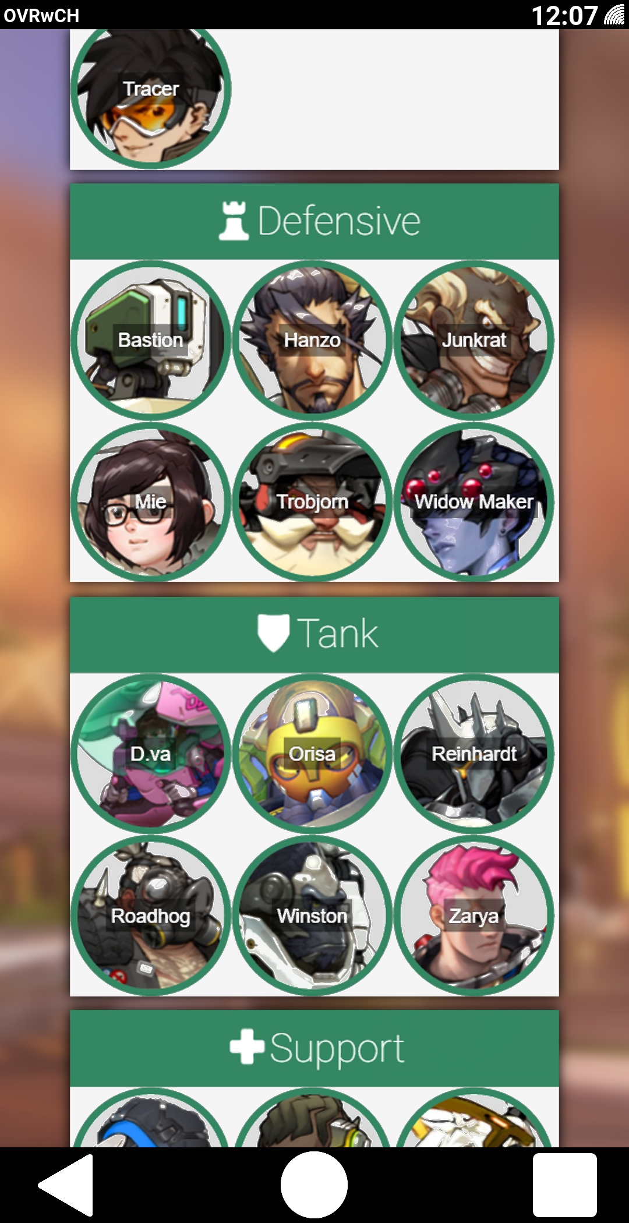

These hero selection screens and process are elaborated further, for dekstop, in folder ‘A’, and for mobile, in folder ‘B’.

There is also a need for users to be able to find counters to heroes. The nature of the “Overwatch” game is much like that of rock - paper - scissors in some respects. With certain heroes possessing abilities and or attributes that make interacting with them dis-advantageous. Finding these counter-heroes when an enemy player is causing problems for your team is a major skill that can win or lose matches. The ‘counter recommendation engine’ offer’s users an advantage over users that are unfamiliar with the counters for certain heroes.

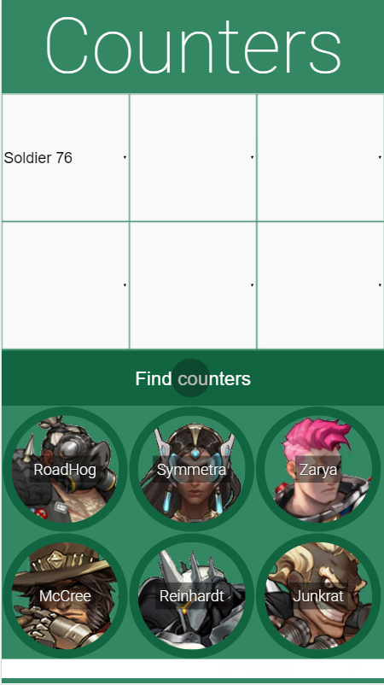

These counter selection screens are continued in folder ‘C’.